
The House of Hackers
Pakistan Cyber Security Learning
LAB REPORT

Linux Fundamentals for Cyber security
Lab 2

Lab Title: Linux Hand-on-Practice
Course Title: 60-Day Ultimate Hacking Course [2025]

Student Name: NOOR UL NISA
Learning Through: The House of Hackers — YouTube
Date of Submission: 25 July 2025

Submitted To

Instructor Name: SYED RAMZAN BUKHARI

YouTube Channel: The House of Hackers

Linkndin: Syed Ramzan Bukharii

🧪 Linux Lab Manual: Basic File & Directory Commands
🎯 Lab Objectives
- Understand Linux file permission model (user, group, others).
- Learn to modify permissions and ownership using CLI.
- Work with traditional permissions and ACLs (Access Control Lists).
- Analyze permission-related metadata using different tools.
🔰 Lab 1: View File Permissions — ls -l
📌 Purpose: View permission details of files .
📘 Syntax: ls -l
🔍 Example:ls -l /etc/passwd
📤 Expected Output: Displays file permissions, ownership, size, and modification date.
✅ Try These Exercises:
- Run ls -l in your home directory.
- Note the structure: -rw-r--r-- 1 user group size date name.
📸 Insert Screenshot Here
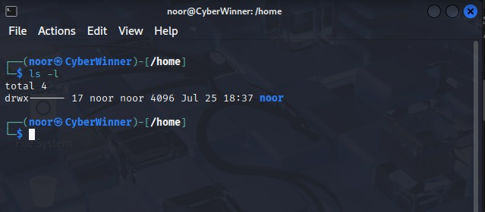

🔰 Lab 2: Change File Permissions — chmod
📌 Purpose: Modify access rights for files/directories
📘 Syntax: chmod [permissions] [file]
🔍 Example: chmod 755 script.sh
📤 Expected Output: File script.sh is set to rwxr-xr-x.
✅ Try These Exercises:
- Create a script demo.sh, and set it to executable (chmod +x demo.sh).
- Use numeric mode (chmod 644 demo.sh) and symbolic mode (chmod u+x demo.sh).
- Observe effects using ls -l.
📸 Insert Screenshot Here
🔰 Lab 3: Change File Owner — chown
📌 Purpose: Change ownership of a file
📘 Syntax: chown [user] [file]
🔍 Example: chown root file.txt
📤 Expected Output: file.txt is now owned by root.
✅ Try These Exercises:
- Create testfile.txt and use chown to assign it to another user (e.g., sudo chown nobody testfile.txt).
- Verify changes with ls -l.
📸 Insert Screenshot Here
🔰 Lab 4: View File Metadata — stat
📌 Purpose: Detailed file information
📘 Syntax: stat [file]
🔍 Example: stat file.txt
📤 Expected Output: Shows inode, permissions, size, timestamps, etc.
✅ Try These Exercises:
- Use stat on multiple files.
- Compare timestamps before and after modification.

📸 Insert Screenshot Here

Bonus: Permission Representation (Quick Reference) Symbol | Permission | Numeric
r | Read | 4
w | Write | 2
x | Execute | 1
rwx | All | 7
--- | None | 0

🔍 Example:
- chmod 755: rwxr-xr-x
- chmod 644: rw-r--r--
📚 Final Task: Ownership + Permissions Challenge
Complete these steps as a practice challenge:
- Create a file and restrict it to read/write for owner only.
- Change ownership to another user.
- Add ACL permission for another user with read-only access.
- Verify all permissions using ls -l, stat, and getfacl.

📸 Insert Screenshot Here
Tips:
- Use sudo when modifying ownerships.
- Combine chmod, chown, and chgrp for secure configurations.
- ACLs are advanced but highly useful in shared environments.

Linux Lab Manual: Searching & Filtering Files
🎯 Lab Objectives
- Learn how to search for files, text, and command paths efficiently.
- Understand the use of find, locate, grep, and related tools.
- Practice recursive searching, regex, and filtering methods.
- Integrate commands for advanced usage (e.g., xargs pipelines).

🔰 Lab 1: Find Files — find
📌 Purpose: Recursively search for files/directories
📘 Syntax: find [path] -name [pattern]
🔍 Example: find / -name "passwd"
📤 Expected Output:All file paths matching passwd.
✅ Try These Exercises:
- Search for all .conf files in /etc: find /etc -name "*.conf"
- Search for a file hosts in root directory: sudo find / -name hosts
📸 Insert Screenshot Here
🔰 Lab 2: Fast File Search — locate
📌 Purpose: Quickly find files using a pre-built database
📘 Syntax: locate [pattern]
🔍 Example: locate bashrc
📤 Expected Output: All paths containing bashrc.
✅ Try These Exercises:
- Run locate passwd.
- Try locate "*.log" to find all .log files.
📸 Insert Screenshot Here
🔰 Lab 3: Update Database — updatedb
📌 Purpose: Update the file location database used by locate
📘 Syntax: updatedb
🔍 Example: sudo updatedb
📤 Expected Output: Database refreshed with latest file locations.
✅ Try These Exercises:
- Create a file testfile.log, then run locate testfile.log before and after running
sudo updatedb.
📸 Insert Screenshot Here
🔰 Lab 4: Search Text in Files — grep
📌 Purpose: Search specific patterns in files
📘 Syntax: grep [pattern] [file]
🔍 Example: grep root /etc/passwd
📤 Expected Output: Displays lines with the word "root".
✅ Try These Exercises:
- Search daemon in /etc/passwd.
- Count matches: grep -c bash /etc/passwd

📸 Insert Screenshot Here
🔰 Lab 5: Regex Pattern Search — egrep
📌 Purpose: Enhanced grep with extended regular expressions
📘 Syntax: egrep [pattern] [file]
🔍 Example: egrep "root|admin" /etc/passwd
📤 Expected Output: Lines containing either 'root' or 'admin'.
✅ Try These Exercises:
- Match users sync or nobody in /etc/passwd.
- Try regex: egrep "^[a-z]+:" /etc/passwd (match usernames)

📸 Insert Screenshot Here
🔰 Lab 11: Identify File Type — file
📌 Purpose: Determine file type
📘 Syntax: file [filename]
🔍 Example: file script.sh
📤 Expected Output: Shows if it's ASCII, script, image, etc.
✅ Try These Exercises:
- Run file on text, PDF, and image files.
- Use file on a binary executable.
📸 Insert Screenshot Here
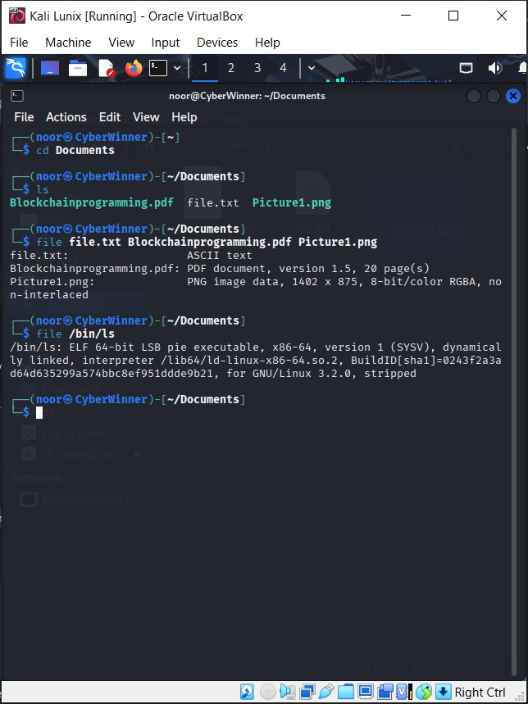

🔰 Lab 12: Get Filename Only — basename
📌 Purpose: Extract file name from path
📘 Syntax: basename [path]
🔍 Example: basename /home/user/file.txt
📤 Expected Output: file.txt
✅ Try These Exercises:
- Extract basename of various paths.
📸 Insert Screenshot Here
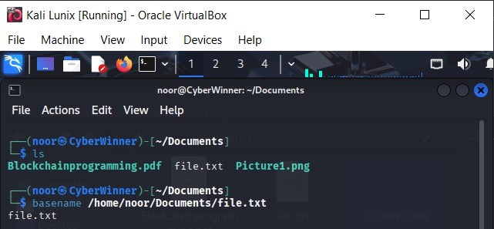
🔰 Lab 13: Get Directory Name — dirname
📌 Purpose: Extract directory path
📘 Syntax: dirname [path]
🔍 Example: dirname /home/user/file.txt
📤 Expected Output: /home/user
✅ Try These Exercises:
- Use dirname on absolute paths.
- Combine dirname and basename in one command.
📸 Insert Screenshot Here
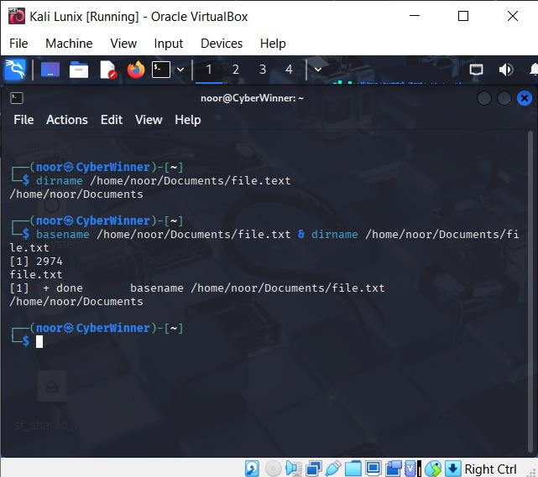
📚 Final Task: Real-World Scenario Practice
Perform these tasks as a complete practice:
- Create a directory LinuxLab and enter it.
- Create files test1.txt, test2.txt.
- Copy them to backup/.
- Rename test1.txt to report.txt.
- Delete test2.txt.
- View file details using stat and type using file.
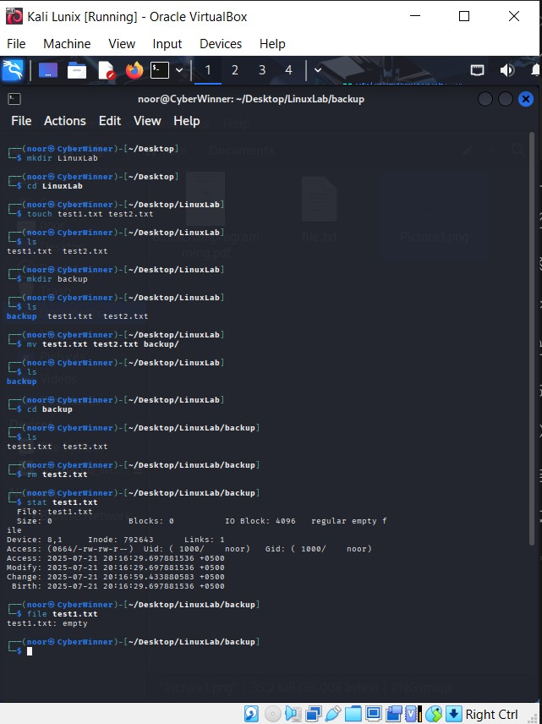
📝 Notes:
- Always double-check before using rm -rf.
- Practice using absolute (/home/user) and relative (../folder) paths.
- These basics are foundational for advanced Linux and scripting tasks.

